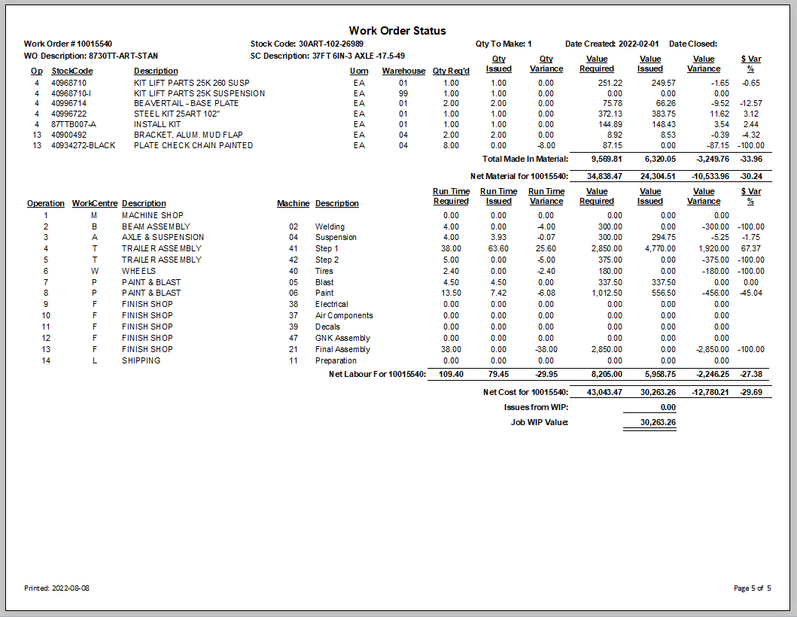
Date the work order was closed. If blank I is still open and in process.
Date the work order was first made.
Material, sub total bought out, made in, sub contact.
Made in subtotal.
Description of the stock code being made.
This is the stock code being made by this work order.
Work order number.

